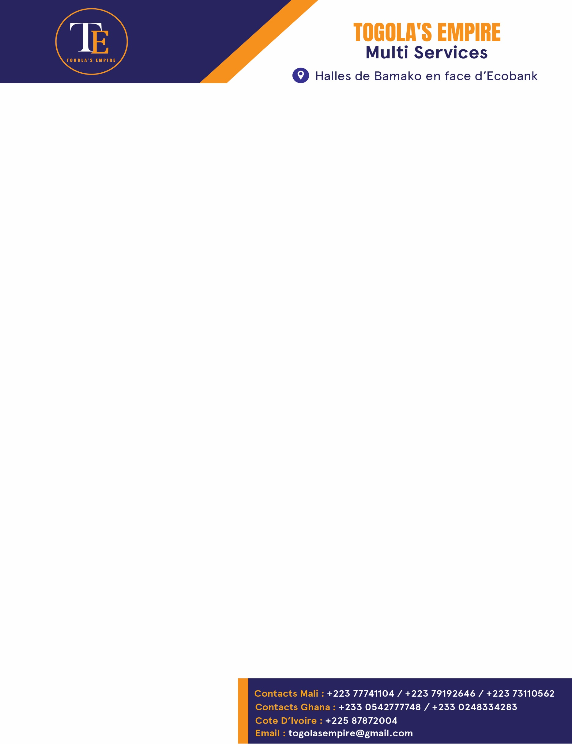

Type your text here

REQUESTING FOR A CONTRACT

Dear Director,

Togola’s Empire. Its main objective is to help Malian students and trainees in Ghana to easily understand and integrate the environment. In our daily tasks, we also used to assist and help them in choosing the right school regarding to their interested field.

Your school is a multicultural environment and a good place to transfer effective, efficient skills and knowledge to students in order to prepare them for the professional world.

We would like to establish a new contract with your school where everyone will win. We are hoping that this contract will create a strong and durable relationship between your school and Togola’s Empire.

We would like to get a discount of 15% out the school fees of any Malian student we will bring to you. This agreement will increase the affluence of students in your school and also help us to meet the unexpected and significant expenses we usually face.

Assured of the consideration you have for future students; we hope that this request will merit your most favorable response.

Thank you very much.

Sincerely.

